**REVISION**

Sign and magnitude

The bit on the far left indicates if it is a positive / negative

The rest of the bits represent the value

1 = negative

0 = positive

10001001 = - 9

The first bit indicates a negative

The other seven (0001001) = 9

Two’s compliment

The bit on the far left indicates if it is a positive / negative

1 = negative

0 = positive

Inverse all the values (0 -> 1)

Add 1

---- ---- ---- ---- ---- ---- ---- ---- ---- ---- ---- ---- ---- ---- ---- ---- ---- ---- ---- ----

**Main factors affecting CPU performance**

**Clock speed**

Clock speed is used to measure how fast the CPU runs and fetches information. Clock speed is measured in hertz.

Measures how fast the CPU can run, relating to the amount of instruction cycles the CPU can deal with in a second.

The speed of the Fetch-Decode-Execute cycle is determined by the CPU’s clock chip. This chip uses a vibrating crystal that maintains a constant rate. The speed of the clock is measured in hertz (Hz) which is the number of cycles per second. A clock speed of 500Hz means 500 cycles per second. Current computers have CPU clock speeds of 3GHz which means 3 billion cycles per second. It is possible to increase the clock speed for a CPU, this is known as overclocking.

** The clock speed represents how much cycles per second can be executed. Can also be referred to as clock rate. Clock speed/Clock rate is measured in gigahertz (Ghz)

**Number of cores**

A single CPU core contains an ALU control unit and registers, however increasing the number of cores means the number of instructions can be increased. Although multiple cores still must communicate through channels meaning clock speed will not double / triple / etc.

**Size of cache**

Cache is used to store data and instructions that the processor will reuse. The larger a cache the more data that can be retained. CPUs can work very quickly but unfortunately only when supplied with data, to overcome this the CPUs cache memory will not just copy the instruction needed at that time, instead it will also copy the continuing instruction. Cache memory has read speeds like the CPU and is therefore much faster than RAM. So, to improve efficiency the CPU’s control unit will look first in the cache for the next instruction to see if it has already been copied which reduces the time taken to access data.

** Cashe is used to store instruction and data that the processor will reuse. The larger a cashe the more data is holds.

**Cashe**

CPU can work very quickly indeed but unfortunately CPU’s can only work when supplied with data. The RAM cannot work at the same speed.

To overcome this the CPU’s cashe memory will not just copy the instruction needed at that time, instead it will also copy the continuing instruction.

Cashe memory has read speed like the CPU and is therefore much faster.

**Three registers in the CPU**

**Program counter – Stores the address of the current instruction**

**Accumulator – Stores results of operations temporarily**

**Memory data register – Stored data received from RAM**

---- ---- ---- ---- ---- ---- ---- ---- ---- ---- ---- ---- ---- ---- ---- ---- ---- ---- ---- ----

**Instruction set**

An instruction set is a set of commands for a CPU in machine code

**Color depth**

An image with a color depth of 1 will display 2 colors as the number of colors allowed is decided by the number of bits available. The number of colors is determined by 2x (x being the number of bits available.)

**Pipelining**

Pipelining is the process of accumulating and executing instruction from the processor. It allows the management of these instructions in an orderly process. Instruction latency increases in pipelined processors.

**Resolution**

The resolution is the number of pixels an image has on screen. It is worked out by multiplying the width by the height (I.e., 1280 x 800 = 1,024,000)

---- ---- ---- ---- ---- ---- ---- ---- ---- ---- ---- ---- ---- ---- ---- ---- ---- ---- ---- ----

**CPU in mobile systems and PC’s (CISC / RISC)**

**CISC**

This type of instruction set will have many known instructions and these will be complex in nature (I.e., each instruction may represent several steps). For example, there may be instructions to multiply 2 numbers. In CISC processors, the actual hardware will be built to automate this instruction and so will LOAD the values, MULTIPLY them, and STORE the result in one operation (which may take several clock cycles).

**RISC**

This type of instruction set has a much smaller number of known instructions. For example, although there may also be an instruction to multiply 2 numbers, in a RISC CPU, this instruction will only represent the multiplication part of the process and not the LOADING and STORING of values. In RISC processors, the instructions are not complex (they are simple) and so a single RISC instruction will not automate all other required steps such as LOAD and STORE. As a result, in RISC, more instructions are required to perform a task.

Although it may seem that RISC is more limited, it has a major advantage over CISC. Because each RISC instruction is simple, each one takes a single clock cycle to be executed. This means that RISC processors can benefit from pipelining, whereby as one instruction is being executed, the next can be decoded and the next fetched all at the same time. CISC instructions would have to be fully executed before the next could be fetched. As a result, RISC instructions will execute at least as fast as CISC.

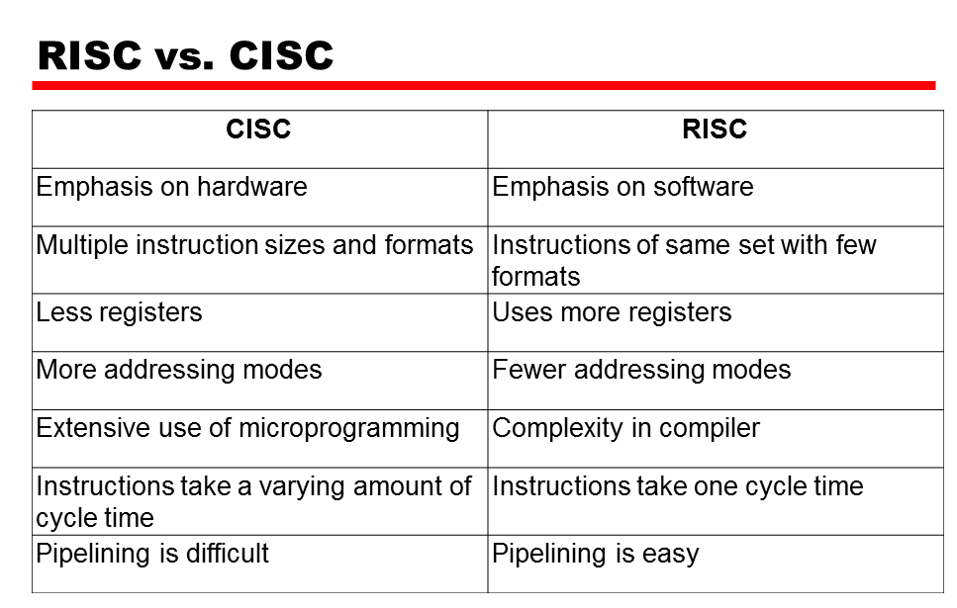

**ASCII**

ASCII (American standard for information interchange) is a 7-bit character set containing 128 characters including numbers, the alphabet, and some special characters. The limited number of characters available in ASCII means that other language tables cannot be represented.

**Arrays and list**

Arrays are static and lists are dynamic

**GUI**

· Easy to use for beginners

· Use lots of memory and processing power

· Can be irritating and slow for experienced users

---- ---- ---- ---- ---- ---- ---- ---- ---- ---- ---- ---- ---- ---- ---- ---- ---- ---- ---- ----

**Lossy and lossless**

**Lossy**

This is when unrequired data is removed from a file. MP3s are an example of this where sound quality may reduce but not to a point which is noticeable by the listener.

**Lossless**

This is when data is temporarily removed from the file but added back (rebuilt) when the file is to be used again. Zip files are an example of this. They will need to be unzipped to be usable again.

Lossy results in a much smaller file, compared to lossless.

|  |  |  |
| --- | --- | --- |
| LOSSY | LOSSLESS | Generic Compression |
| Removes unnecessary info. | Not the best at reducing file size | File storage requirement is reduced |
| Cannot get back original copy | You can get back the first copy | Uses bandwidth |
| Compatible with MP3 and JPEG | Compatible with ZIP AND GIF | Less time is needed for downloading |
| Used for multimedia files | Useful for computer program files | Helps occupy disk space and overall storage |

**Image data**

Image data is stored through meta data which includes the width, height, resolution, etc. and is represented in binary. This can affect the visual quality of the image and may limit the amount of color depth available.

---- ---- ---- ---- ---- ---- ---- ---- ---- ---- ---- ---- ---- ---- ---- ---- ---- ---- ---- ----

**What is an MFD?**

It is a device that allows printing, copying, and scanning as well as providing additional functionality, such as scanning to email. Multifunctional devices are faster than conventional printers and have faster print speeds.

**What do we mean by secondary storage?**

To keep data and programs indefinite, secondary storage is necessary. If secondary storage were not used, all data and programs would be lost when the computer is turned off.

**Give an example of an input device?**

* Keyboard
* Mouse
* Scanner
* Camera
* Microphone

**Give an example of an output device?**

* Monitor
* Speakers
* Printer
* Headphones
* projectors

**What is one benefit of optical storage?**

Compared to other types of storage, optical is most durable.

---- ---- ---- ---- ---- ---- ---- ---- ---- ---- ---- ---- ---- ---- ---- ---- ---- ---- ---- ----

**What is the purpose of the CPU?**

* The CPU is often known as the brain of the computer
* Its job is to process data. (Search, sort, make choices and calculate)
* When using a computer, it is the CPU which is at the heart of everything.

The main components of the processor include the following:

* Control unit (CU)
* Arithmetic Logic Unit (ALU)
* Register
* Buses

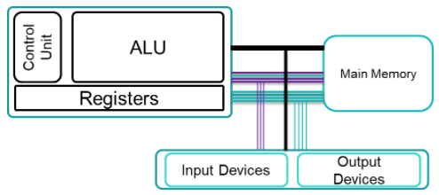

**The Accumulator (ACC)**

The accumulation of the CPU is a register which temporarily holds data values in logic and mathematic equations.

**The Program Counter (PC)**

Program counter holds the address of the instruction which is currently being executed. The program counter increases by 1 each time an instruction is fetched.

**The Memory Address Register (MAR)**

The memory address register holds the place of data which needs to be accessed.

**The data bus**

This bus is responsible for moving data between the CPU and the main memory.

**The Address bus**

This bus is responsible for communicating the memory locations of the data instruction that needs to be fetched between devices.

**The control bus**

This bus is responsible for communicating control signals from the control unit.

---- ---- ---- ---- ---- ---- ---- ---- ---- ---- ---- ---- ---- ---- ---- ---- ---- ---- ---- ----

* **Multi-functional devices**

It is a device that allows printing, copying, and scanning as well as providing additional functionality, such as scanning to email. Multifunctional devices are faster than conventional printers and have faster print speeds.

* **Personal computers**

An end user directly operates a personal computer rather than a computer expert or technician. Personal computers are intended for end users to operate directly. Can only be used by one person at a time.

* **Mobile devices**

A mobile computing device transports a computer during normal use to allow the transmission of data, voice, and video. Mobile computing is an interaction between humans and computers that involves mobile communications, mobile hardware, and mobile software.

* **Servers**

Several programs or devices, called clients, can communicate with each other using a server. This architecture is called the client–server model.

---- ---- ---- ---- ---- ---- ---- ---- ---- ---- ---- ---- ---- ---- ---- ---- ---- ---- ---- ----

**Research the functions**

**CPU**

CPUs are primarily responsible for retrieving and executing instructions.

**RAM**

A computer's RAM handles all active tasks and apps. Without RAM, it would be impossible to run programs, play games, or stream online content.

**Secondary Storage**

To keep data and programs indefinite, secondary storage is necessary. If secondary storage were not used, all data and programs would be lost when the computer is turned off.

**Graphics Adapter**

Graphics card also called graphics adapter, is an interface between a computer and a monitor. The graphical information computed by a CPU transferred through this card to display images on a screen

---- ---- ---- ---- ---- ---- ---- ---- ---- ---- ---- ---- ---- ---- ---- ---- ---- ---- ---- ----

**Form factor**

We use form factors in hardware designs so we can describe the shape, size, and many other specs of components.

**Power efficiency**

In computers, power efficiency is the rate of computations which can be sent over by a computer for each watt transmitted.

**Cost**

Costs of computers are having a budget. The spending on storage and processors is also an area to focus on.

**Required performance**

Required performance relies on how accurate the computer is. One way you can check this is by doing work on the computer and seeing if it's too slow or if there are any bugs.

**Compatibility**

Compatibility is checked to see if you can run 2 software's at once. If you are unable to do so, then your computer is not compatible.

---- ---- ---- ---- ---- ---- ---- ---- ---- ---- ---- ---- ---- ---- ---- ---- ---- ---- ---- ----

**Stacks**

* Elements are sorted by insertion order.
* Last element in is first out
* Elements have no index
* Can only add to top and remove from top

Push/pushed - add pop/popped - removed

**Queue**

* Elements are sorted by insertion order
* First element in is first out
* Elements have no index
* Can only add to back and remove from front

Enqueue – add Dequeue – remove

---- ---- ---- ---- ---- ---- ---- ---- ---- ---- ---- ---- ---- ---- ---- ---- ---- ---- ---- ----

**Output and storage**

**Magnetic Storage**

Magnetic storage is data storage in a magnetized environment. Magnetic storage is a form of non-volatile memory using different magnetization patterns in magnetizable materials to store data. Use one or more read/write heads to access information. The magnetized points represent 1 and the demagnetized areas represent 0

**Optical Storage**

The way we write data to an optical storage is by burning lasers onto the pits, into the flat surface called the land.

for us to read data of optical storage, a laser is shone on the surface. While the laser hits the ground it represents (0), but when it hits the pits, it represents (1).

**Solid State Storage**

Sold state is non-volatile, it also stores and recovers information using only circuits of electronics, they don’t have any moving mechanical parts.

**HDD (Hard Disk Drive)**

|  |  |
| --- | --- |
| **Use** | They can store operating systems, programs and files. |
| **Capacity** | Can range from 250GB to 20TB. |
| **Speed** | 5,400 RPM – 10,000 RPM. |
| **Portability** | Big and heavy to carry around, therefore not portable. |
| **Durability** | If it falls it can break and won't work due to the damage. |
| **Reliability** | Long lasting and can be reused. |

**CD disk**

|  |  |
| --- | --- |
| **Use** | Can hold small files, images and videos. |
| **Capacity** | Roughly 680 MB. |
| **Speed** | 154 KB/s. |
| **Portability** | Easily portable due to its light weight and small size. |
| **Durability** | 50/50 can survive drops but gets damaged by scratches. |
| **Reliability** | CD-RW can be rewritten too. |

**USB stick**

|  |  |
| --- | --- |
| **Use** | Transferring files and data from one desktop to another. |
| **Capacity** | 256Mb – 64GB varies with price. |
| **Speed** | Very fast. |
| **Portability** | Highly portable because it is small and lightweight. |
| **Durability** | No moving parts and can still work if scratched. |
| **Reliability** | Can be used repeatedly. |

---- ---- ---- ---- ---- ---- ---- ---- ---- ---- ---- ---- ---- ---- ---- ---- ---- ---- ---- ----

**Image representation**

**Starter:**

**What does ASCII stand for?**

American Standard Code for Information Interchange.

**How many characters are in the ASCII character set?**

In ASCII, there are 128 different characters that can be represented in 7-bits of code.

**What is the difference between ASCII and Unicode?**

ASCII uses lowercase letters (a-z), uppercase letters (A-Z), digits (0-9) and punctuation marks to represent letters, whereas Unicode uses symbols. Unicode also uses more languages and math's symbols

**Bitmap**

* The ability to produce high-quality images.
* Using an array of memory to store pixel data, bitmap files can be easily created.

**Vector**

* Size of file is smaller.
* You can scale the image without losing any quality.

**a)What is metadata and why does it need to be included in the file?**

A file starts with meta data that tells the computer how it should process the data.

**b) What does pixelate mean?**

Pixelated is when an image is created by using 1 and 0. The outcome of this is a grid which makes an image using only black and white tiles.

**a) Discuss the effect of color depth and resolution on the size of an image.**

1 bit allows 2 values meaning you can have two shades of color on your image. If your image is 2 bits, then you can have up to 4 shades of color.

**b) Which three colors are used to make all three colors on a computer?**

RGB: RED, GREEN and BLUE

**Discuss direct color and explain how color is stored this way**

Direct color is made up by mixing RGB. This will create a hex color.

**Firstly, why do you think that we compress images?**

Over-sized files will eat up bandwidth, leading to slower online performance.